Some guidelines for setting up Co-operative Groups

For many teachers, group work is seen as dividing the class into more or less equal groups, and then setting a task which they are expected to accomplish all together. This is unlikely to produce the best results. To make cooperative learning in groups more effective than competitive or individualistic learning, effort has to be put into planning and designing groups and group activities.

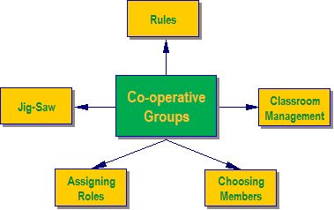

A] Rules
In order for groups to function well, all members need to have the same expectations and understanding of what is required. Before the groups begin their task, the setting up of "rules" is a good idea. These can be brainstormed and negotiated, or they can be given a rubric to assess how their group functions. The rules can be general, or they can be specific to the task.

General rules can be used for all cooperative group work.
- A poster with general rules for group behaviour is a useful tool. This can be printed and displayed in the classroom or computer centre.

Specific rules need to be drawn up by the class, and are often only needed for the specific project.
- These could be about the sharing of electronic or book resources, or about the amount of time allowed for each activity.
- A timeline for implementation is an important part of any project, and all group members need to know and accept the deadlines.

B] Managing the Classroom
This is often one of the aspects of cooperative learning that frightens teachers the most. Group work is often noisy and requires more space than straight rows of desks. Careful planning needs to be done in order to accommodate both the physical space needed and the noise. Warning management and other colleagues is often a good idea before starting the activity. Allowing learners to work outside may solve the space problem, but may make it difficult to oversee all the groups. Cooperative group learning cannot happen effectively on the spur of the moment – it requires thoughtful planning.

Think about:
- Whether you can move your desks to create small groups.
- How much floor space is available for the making of posters, etc?
- If you send groups outside, are you able to oversee them? Will they make a noise and disturb another class? Is there a space that is conducive to work, e.g. a garden table or bench?
- Will the librarian allow a group to work in the library?
- Is there any space in the admin block that a quiet, responsible group could use?
- Which groups need to be near you because of the noise they make?

C] Choosing the Groups
If learners are left to choose their own groups, the groups tend to be fairly homogenous. Invariably, friends work together and there will often be someone who no-one wants to work with. While allowing friends to work together may promote harmony, it may not always lead to optimal learning.

In the early stages of cooperative group work, it is probably a good idea for the teacher to select the groups. Once everyone knows how the groups are meant to function, learner-selected groups have a better chance of functioning well.

For more details, look at http://www.unicef.org/teachers/teacher/co-op.htm .

D] Assigning Roles
There are many formal roles that can be allocated to members of a group, e.g. Taskmaster, Gatekeeper, Praiser, Recorder, etc. In the interests of simplicity we will avoid these and list some general social roles that all group members should play, whenever appropriate. These are the roles which make cooperation in a group possible.

Some expected behaviours:
- Everyone contributes and helps.
- Everyone listens to others with care.
- Encourage everyone in your group to participate.
- Praise helpful actions or good ideas.
- Ask for help if you need it.
- Check to make sure everyone understands.
- Stay on-task with your group.

Each individual is responsible for:
- Trying
- Asking
- Helping
- Courtesy.

As a team, they are responsible for:
- Solving
- Consulting with other groups if they are confused
- Helping our group members and other group members (if asked)
- Working together to achieve tasks and goals.

Adapted from: Information on Co-operative Learning: Penn State Commonwealth College – Physical Therapist Assistant Program, available at http://www.ma.psu.edu/~pt/group/cooplrn.htm.

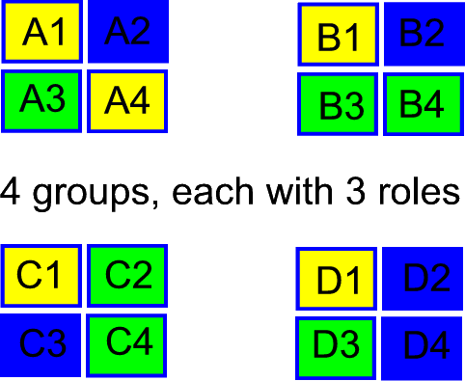
E] Jig Saw Approach
In order to make sure everyone in the group does their fair share of work, the teacher can set specific tasks for each member to do. It is only when all these tasks are complete that the project can be completed. The pieces fit together like a jig-saw puzzle. More experienced or older groups can divide the labour themselves – with novice or younger groups, it is probably wise for the teacher to assign the tasks.
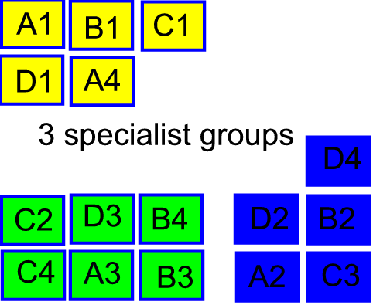
Learners in specialist roles (performing a certain function in the group) in each group could meet and collaborate in specialist groups.

Cooperative vs. Traditional Groups
Cooperative group work is not the same as traditional group work, where learners are instructed to sit together in a group and ‘work together’ on a project. For the purposes of this module, cooperative learning can be described as "The instructional use of small groups through which students work together to maximise their own and each other’s learning". There is a sharing of responsibility and information as well as working together for a common purpose.

This table shows some of the differences between traditional groups and cooperative learning groups.

Adapted from Information on Co-operative Learning: Penn State Commonwealth College – Physical Therapist Assistant Program, available at http://www.ma.psu.edu/~pt/group/cooplrn.htm.

