KD Module III: Pedagogy
Unit 3: PBL Cooperative and Collaborative Strategies

Objectives:
Teachers are able to design unit plans and classroom activities so that students engage in reasoning with, talking about and using key subject matter concepts while they collaborate to understand, represent and solve complex real-world problems, as well as to reflect on and communicate solutions (UNESCO ICT-CFT, KD.3.d).

Teachers are able to manage student project-based learning activities in a technology-enhanced environment. (UNESCO ICT-CFT, KD.5.b)

Duration:
Total of 6 notional hours – 3 hour computer practical session and 3 hour self-study on a computer.

A] Computer Practical (Total 3 hours)

Notes to Facilitator
Set up the venue so that the Commonwealth Certificate for Teacher ICT Integration tutorials can be accessed from the computers. The purpose of this practical is to provide participants with clear directions so that they can continue to design a PBL project. We will be accessing one of the Commonwealth Educator’s Network elective modules entitled ‘Learning with Projects’, this time looking at the sections on Collaboration and Cooperation. For clarity purposes, the activity has been separated out from the web tutorial and is recreated here. Provide guidance and assistance so that participants can access and do the tutorial described below.

Task 1: Commonwealth Certificate for Teacher ICT Integration Tutorial (3 hours)
Complete the following CCTI tutorial.

Elective Module 9 – Learning With Projects
Adapted from section on Collaboration

In project-based learning we can define "Collaboration" as meaning work between learners, teachers and others in the community, so that data, knowledge and ideas are shared among them, and they form a Learning Community working towards a common product. This is not the only definition of Collaborative learning. Some theorists see it in a far more complex way. If you are interested in this topic, go to the article by Ted Panitz entitled "A Definition of Collaborative vs. Cooperative Learning".

Collaborative projects can take place between classes in one school, or between classes in different schools. The use of technology in collaborative projects has made distance learners and teachers more accessible. The use of communication tools on the Internet allows for quick and sometimes almost immediate access to other learners, thus saving time and keeping the interest level high. It can also be a powerful motivator, especially for learners who seldom have the opportunity to interact with other learners from other communities or even other countries.

Collaborative learning allows learners access to other ideas and perspectives.
Learners have an opportunity to practise real-life data collection and it enables the broadening of horizons. Teachers have the opportunity to share ideas and experiences with other teachers, and to develop their community of learners beyond their immediate circle. For many teachers this is both motivating and encouraging.

Characteristics of Collaborative Learning

- Enhances learning – learners gain rich insights from cross-class exchanges.
- Encourages ownership of ideas – each group shapes a part of the interaction for the group.
- Develops reading/writing skills – learners use written communication skills to exchange ideas.
- Enhances teaching curriculum – provides an exciting and innovative forum for teaching traditional subjects.
- Stimulates teacher creativity – teachers develop new instructional techniques by sharing project ideas with other colleagues.
- Expands teaching and learning horizons – collaborative projects take learners beyond the classroom to draw on family and community resources for information, making them more aware of their social and physical surroundings.
- Integrates computer and telecommunications technology – teachers and learners learn technical skills.

Adapted from: Learning Circles by Margaret Riel

Collaborative projects do not need to be done using the Internet. Collaboration can take place between two classes that can meet with each other face to face – e.g. within the same school or community. However, telecommunication adds interest and motivation to collaboration, and has the advantage of adding different people's perspectives to the subject being studied.

Collaborative online learning can take different forms. Here are some ideas for further collaborative activities.

Ideas for other Collaborative Activities

“Collaborative learning isn't anything new. Small group discussions and study sessions are collaborative learning activities that have been used in education and training for decades. So what is collaborative online learning? Is it simply a bunch of buzzwords or is it a valid instructional strategy?”

From “Collaborative Online Learning” by Audrey Choden

Collaborative activities can take many forms and can involve individuals or groups.

It should involve four things:

- Two or more peers with a shared learning goal;
- A workspace or learning environment that allows for collaboration;
- An interactive, facilitated process or structure for the learning experience;
- One or more electronic or computerised tools to support collaboration activities.

Adapted from: “Collaborative Online Learning” by Audrey Choden: http://www.trainingbydesign.com/Collaborative.htm

E-mail
In the school context, e-mail collaboration is probably the simplest starting point, either one on one, group to group, or class to class.

“Key pals” is a name used to describe “pen pals” who correspond through e-mail. There are many sites that help teachers and learners to find key pals. This address will take you to a key pal site:
http://www.teaching.com/keypals/.

The simplest form – writing e-mails to other learners – is not really collaborative learning, although it can be an introduction to more collaborative projects. The disadvantage of undirected e-mail correspondence is that content is often very mundane and is not enhanced by the use of technology, e.g. “Hello Sipho, I like soccer.” To make this type of correspondence more collaborative, it is necessary to have a focus, as both correspondents are needed to make it succeed.

Internet
Internet projects in which different classes participate in the same project are more ambitious but very rewarding. There are many examples of collaborative projects on the Internet. Investigate these web sites (some of them are specific projects, while others are directories of projects you can read about or subscribe to):

- US department of Education – Teacher Resources
http://www.doversherborn.com/highschool/libmed/teachers.html
- Down the Drain
http://k12science.org/curriculum/drainproj/
- Where to find collaborative Internet Projects
http://www.northcanton.sparcc.org/%7Eelem/Collaborativeprojects.htm
- Springfield School in Cape Town
http://www.sfc.wcape.school.za/comproj1.htm
- Global Schoolhouse Network
http://www.gsn.org/
- Using Computers in Environmental Education
http://eelink.umich.edu/Computers/ol-projects.html
- Kidproj in Kidspace
http://www.kidlink.org/KIDPROJ/

“Collaborative Internet projects are learning activities structured around goals and objectives that require participants to use the Internet. Projects are usually specific in nature and last for a given period of time. They are announced over the Internet, in newsletters or in other professional publications in "calls for collaboration”. Teachers join them by sending an e-mail to the project facilitator. Multiple classes are involved, many times from around the world. Students collaborate on accomplishing the goals and objectives of the project. While working on these ventures, students acquire a wealth of knowledge about the topic as well as gain many additional benefits.”

Collaborative Internet Projects, Presented by John Simi Loudon County Schools' Technology Academy

Activities
- Investigate the various linked examples above where collaboration has been included in a PBL project.
- Now that we have some general ideas we need to incorporate them into your planning document. Here is the empty planning template but it is preferable that you update the version of this document you started in the previous lesson.
- Scroll down to the section on Collaboration and insert your ideas about how you will attempt to incorporate collaborative strategies in your PBL project.
- Save this template so that you can access it again. We will use it again.

B] Self Study (Total 3 hours)

Task 1: Commonwealth Certificate for Teacher ICT Integration Tutorial (3 hours)
Complete the following CCTI tutorial.

Elective Module 9 – Learning With Projects
Adapted from section on Cooperation

Cooperation is the foundation of many project-based activities. It is one of the valuable life skills that a sound education system should develop in learners. In this activity you will develop an understanding of cooperative groups and implement the first part of your project.

Some guidelines for setting up Co-operative Groups

For many teachers, group work is seen as dividing the class into more or less equal groups, and then setting a task which they are expected to accomplish all together. This is unlikely to produce the best results. To make cooperative learning in groups more effective than competitive or individualistic learning, effort has to be put into planning and designing groups and group activities.

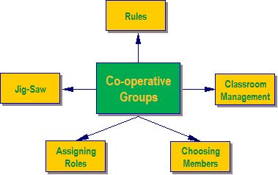

A] Rules
In order for groups to function well, all members need to have the same expectations and understanding of what is required. Before the groups begin their task, the setting up of "rules" is a good idea. These can be brainstormed and negotiated, or they can be given a rubric to assess how their group functions. The rules can be general, or they can be specific to the task.

General rules can be used for all cooperative group work.
- A poster with general rules for group behaviour is a useful tool. This can be printed and displayed in the classroom or computer centre.

Specific rules need to be drawn up by the class, and are often only needed for the specific project.
- These could be about the sharing of electronic or book resources, or about the amount of time allowed for each activity.
- A timeline for implementation is an important part of any project, and all group members need to know and accept the deadlines.

B] Managing the Classroom
This is often one of the aspects of cooperative learning that frightens teachers the most. Group work is often noisy and requires more space than straight rows of desks. Careful planning needs to be done in order to accommodate both the physical space needed and the noise. Warning management and other colleagues is often a good idea before starting the activity. Allowing learners to work outside may solve the space problem, but may make it difficult to oversee all the groups. Cooperative group learning cannot happen effectively on the spur of the moment – it requires thoughtful planning.

Think about:
- Whether you can move your desks to create small groups.
- How much floor space is available for the making of posters, etc?
- If you send groups outside, are you able to oversee them? Will they make a noise and disturb another class? Is there a space that is conducive to work, e.g. a garden table or bench?
- Will the librarian allow a group to work in the library?
- Is there any space in the admin block that a quiet, responsible group could use?
- Which groups need to be near you because of the noise they make?

C] Choosing the Groups
If learners are left to choose their own groups, the groups tend to be fairly homogenous. Invariably, friends work together and there will often be someone who no-one wants to work with. While allowing friends to work together may promote harmony, it may not always lead to optimal learning.

In the early stages of cooperative group work, it is probably a good idea for the teacher to select the groups. Once everyone knows how the groups are meant to function, learner-selected groups have a better chance of functioning well.

For more details, look at http://www.unicef.org/teachers/teacher/co-op.htm .

D] Assigning Roles
There are many formal roles that can be allocated to members of a group, e.g. Taskmaster, Gatekeeper, Praiser, Recorder, etc. In the interests of simplicity we will avoid these and list some general social roles that all group members should play, whenever appropriate. These are the roles which make cooperation in a group possible.

Some expected behaviours:
- Everyone contributes and helps.
- Everyone listens to others with care.
- Encourage everyone in your group to participate.
- Praise helpful actions or good ideas.
- Ask for help if you need it.
- Check to make sure everyone understands.
- Stay on-task with your group.

Each individual is responsible for:
- Trying
- Asking
- Helping
- Courtesy.

As a team, they are responsible for:
- Solving
- Consulting with other groups if they are confused
- Helping our group members and other group members (if asked)
- Working together to achieve tasks and goals.

Adapted from: Information on Co-operative Learning: Penn State Commonwealth College – Physical Therapist Assistant Program, available at http://www.ma.psu.edu/~pt/group/cooplrn.htm.

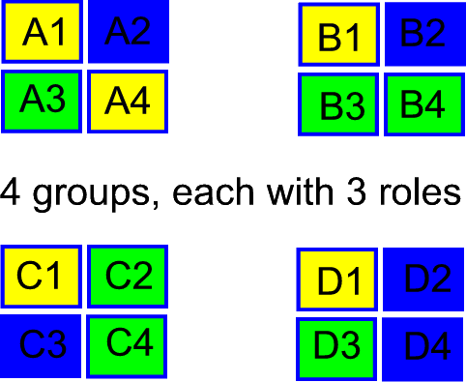
E] Jig Saw Approach
In order to make sure everyone in the group does their fair share of work, the teacher can set specific tasks for each member to do. It is only when all these tasks are complete that the project can be completed. The pieces fit together like a jig-saw puzzle. More experienced or older groups can divide the labour themselves – with novice or younger groups, it is probably wise for the teacher to assign the tasks.
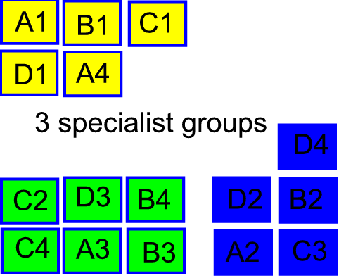
Learners in specialist roles (performing a certain function in the group) in each group could meet and collaborate in specialist groups.

Cooperative vs. Traditional Groups
Cooperative group work is not the same as traditional group work, where learners are instructed to sit together in a group and ‘work together’ on a project. For the purposes of this module, cooperative learning can be described as "The instructional use of small groups through which students work together to maximise their own and each other’s learning". There is a sharing of responsibility and information as well as working together for a common purpose.

This table shows some of the differences between traditional groups and cooperative learning groups.

Adapted from Information on Co-operative Learning: Penn State Commonwealth College – Physical Therapist Assistant Program, available at http://www.ma.psu.edu/~pt/group/cooplrn.htm.

Working in cooperative groups can be a great motivator, allowing children to enjoy the company and ideas of others as well as finding out more about themselves.

Activities
- Investigate the content and linked examples above of where cooperative learning has been included in a PBL project.
- Now that you are aware of the advantages, incorporate cooperative learning into your planning document. Here is the empty planning template but it is preferable that you update the version of this document you have used on two previous occasions.
- Scroll down to the section on cooperation and insert your ideas about how you will attempt to incorporate those strategies in your PBL project.
- Save this template so that you can access it again. We will use it later.

Resources Used in this Lesson Unit

SchoolNet SA/SCOPE. (2011). Commonwealth Certificate for Teacher ICT Integration: Learning with Projects Module. Available online at http://www.schoolnet.org.za/CoL/ACE/projectbased/activities/pbl.index.htm. Accessed 16/08/2011 (© All Rights Reserved. Free to use online.).

